

**VEHICLE JOB CARD *Job Car No:***

|  |  |  |  |  |  |  |
| --- | --- | --- | --- | --- | --- | --- |
| **Inbound Details** | | **Vehicle Details** | | **Job Request** | **Outbound Details** | |
| **Date** |  | **Call Sign** |  | * **PM** * **Mechanical** * **Clutch** * **Electrical** * **Fabrication** * **Tires** * **AC** * **Brake** * **Suspension** * **Engine** | **Date** |  |
| **Time** |  | **Reg No** |  | **Time** |  |
| **Odometer** |  | **Make & Model** |  | **Odometer** |  |
| **EVO Name** |  | **Fuel Level** | * **Empty** * **Half** * **Full** | **EVO Name** |  |
| **EVO Contact** |  | **EVO Satisfaction** | * **Yes** * **No** |
| **EVO Sign** |  | **Station** |  | **EVO Sign** |  |

**Job Requisition/ Reported Defect: Body Inspection Report** (Mark with “X” where damage)

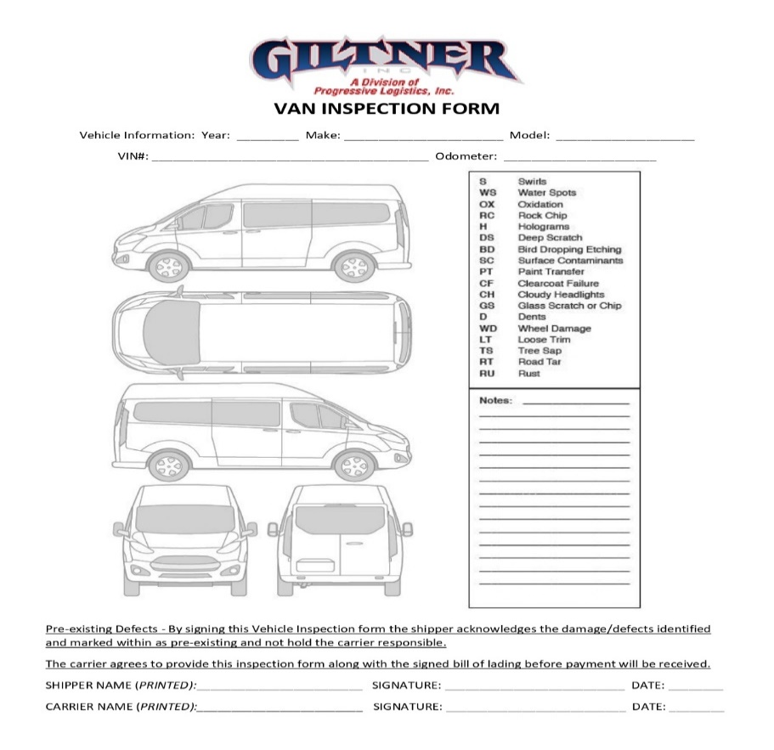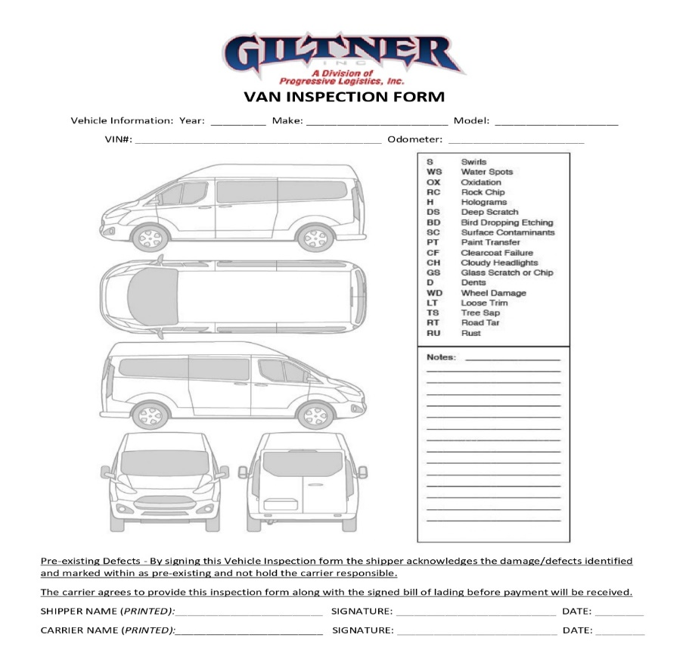

|  |
| --- |
|  |

**Vehicle Body Report Comments:**

|  |
| --- |
|  |

**Work History**

|  |  |  |  |
| --- | --- | --- | --- |
| **S. No** | **Date** | **Job Done** | **Job Done By** |
|  |  |  |  |
|  |  |  |  |
|  |  |  |  |
|  |  |  |  |
|  |  |  |  |
|  |  |  |  |
|  |  |  |  |

**Parts Utilization**

|  |  |  |  |  |  |
| --- | --- | --- | --- | --- | --- |
| **S. No** | **Part Name** | **Qty** | **S. No** | **Part Name** | **Qty** |
|  |  |  |  |  |  |
|  |  |  |  |  |  |
|  |  |  |  |  |  |
|  |  |  |  |  |  |

_____________ _____________ _____________ ____________

**Service Advisor Parts In-charge (If applicable) Workshop Supervisor Fleet Manager**